

GRAPHIC ERA DEEMED UNIVERSITY

DATA STRUCTURE IN C++ – T360

LibraMind
An Intelligent Digital Library and Personalized
Book Recommendation System

PROJECT-BASED LEARNING– PHASE-I

PROJECT AND TEAM INFORMATION
Project Title
LibraMind (An Intelligent Digital Library and Personalized Book Recommendation System)

Student / Team Information
Team Name: Code Crafters | Project Type:  Project-Based Learning (PBL)
Team member 1 (Team Lead) |   Pal, Ishan- 2510012038  Ishanpal54@gmail.com
Team member 2 | 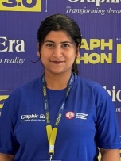  Saini, Samiksha- 25101281166  Sainisamiksha013@gmail.com
Team member 3 |   Gusain, Vedansh- 2510012637  Vedanshgusain1@gmail.com

Course: B.Tech- Computer Science Engineering Academic Year: 2026-2027
Mentor: Dr. Hemant Pokhariya

PROPOSAL DESCRIPTION

Motivation
Stand in front of a library shelf with a few thousand books, and you'll see the problem fast — there's no shortage of books, just no real way to figure out which one is worth picking up. Most college and community libraries are still using outdated registers or search boxes that only work if you type the exact title, which is fine if you already know what you want. It's not much use if you don't. That's the gap we're trying to close: a system that keeps track of the books properly on one side and, on the other, nudges a reader toward something new based on what they've read before. Nothing fancy — just enough to save people time, give smaller libraries a cheap way to modernise, and maybe make picking a book feel a bit more like getting a tip from a friend than digging through a dusty Catalog.

State of the Art / Current solution
Look at what's out there already, and it's mostly the same handful of features: add a book, search by title or author, mark something issued or returned. Fine for record-keeping, but that's about where it stops — recommendations basically don't exist at this scale. Then you've got Goodreads and Amazon on the complete opposite end, doing recommendations really well, but they're massive commercial platforms, not something you can crack open and learn from as a student, let alone adapt for a small library. So that's where we're aiming: something in between, small enough to build and actually understand from the ground up, but still able to suggest books using nothing more exotic than the data structures and OOP concepts we're already learning in this course..

Project Goals and Milestones
In short, We want a Digital Library manager that stores, searches, issues, and returns books without any fuss, and that also recommends books based on what a user has already read. Here's roughly how we're planning to get there:
Milestone 1: Design the book and user data structures, then get the core operations — add, delete, search, issue, return — actually working in C.
Milestone 2: Speed things up with proper searching and sorting — linked lists, binary search trees, hashing, the works.
Milestone 3: Move over to C++ and design the object-oriented side of things for users, books, and the recommendation logic, using classes, inheritance, and polymorphism.
Milestone 4: Actually build the recommendation engine — matching on genre, author, and whatever the user has read before.
Milestone 5: Test it, fix what's broken (there will be something), and put together the final report and demo.

Final Goal: Show a working model that demonstrates library management and book recommendations.

Project Approach
We're building this in two connected halves. The first is the core library engine, written in C, mostly because C gives us direct control over memory and speed — something that actually matters once the book list gets big. Books sit in a linked list, and we're using a binary search tree so we can look a title up quickly instead of scanning through every single record like it's 1995. A hashing scheme takes care of fast lookups by a book's ID, and a couple of sorting routines let us arrange things by title, author, or popularity, whichever the situation calls for.
The second half is where the object-oriented programming comes in — the recommendation and user-management layer, written in C++. We're planning classes for Book, User, and Library, with inheritance handling the different account types (Student vs. Admin, mainly) and polymorphism so each type of account behaves the way it's supposed to without a mess of if-else checks everywhere. The recommendation part itself isn't as complicated as it sounds — compare what a user has already read against everything else in the catalogue, and pull out the closest matches by genre or author. We'll build and test all of this on a regular machine with a standard C/C++ compiler like GCC, and we're keeping the interface a plain command-line menu on purpose, so the time goes into getting the logic right instead of fighting with a UI.

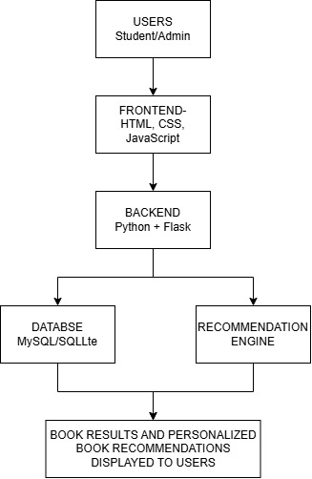
System Architecture

The part of the app that users see and use is called the frontend, and the Flask part works behind the scenes to handle the requests and manage the rules and logic of the app. The database keeps all the information that is saved, and the recommendation system checks what users have read along with details about the books to provide personalized suggestions, which are then shared with the user.

Project Outcome / Deliverables
When it's done, we're handing in a working library application — add, search, issue, return, plus a recommendation feature that suggests titles to each user. Along with that: The Full source code in C and C++, a sample Dataset of Books to test with, a short user guide, and a Final Report that walks through how we designed and tested the thing.
.

Assumptions
A couple of things we're taking for granted here. First, that the library's data — books and users — stays small enough for plain file storage to handle, no need for a full database server. Second, that only one person is using the system at a time, so we're not building for several people hitting it simultaneously in this version.

Conclusion
Our intelligent digital library system makes library work easy and fast. Students can easily search books and find the books they need .It also helps students to get book recommendation according to their interest and study needs. This system saves time and reduce manual work a.IT gives better and simple library experience to students .In future we can also add more features like AI based recommendation ,online reading book reviews and smart search. Overall our project is a simple step towards making the traditional library more smart, useful and student friendly.

References
1. GeeksforGeeks — Tutorials on Data Structures and Algorithms (Linked Lists, BSTs, Hashing, Sorting).
2. GeeksforGeeks — Object-Oriented Programming Concepts in C++.
3. cplusplus.com — C++ Standard Library reference.
4. Course lecture notes and lab material.

